Roving for Stocks
  - A Presentation to the Boston Investors’ Group
  - 7:00pm, February 24, 2016

  - Alexandra Reisman, Communications Manager
  - alex.reisman@stockrover.com

Presentation Goals
- Demo Stock Rover features to help you find and pare down a list of stocks.
- Focus on initial research, point out options for drilling down further

Market Context
- Stock Rover Markets
- Stock Rover Weekly Brief
- Chart sectors vs. S&P 500 over 1, month, 3 months, 1 year

Screening
- Basic screening – simple filters, e.g...
ROA > 5%
- Equation screening – metric comparison or more complex filters, e.g...
ROA [now] >= ROA [1 year ago]
Sales [now] >= 2*Sales [2 years ago]
- Ranked screening – weighting criteria for a score and rank, e.g....
30% on profitability metrics such as ROA, 30% on growth metrics such as sales change, 40% on valuation metrics such as P/E

Example using all three methods:

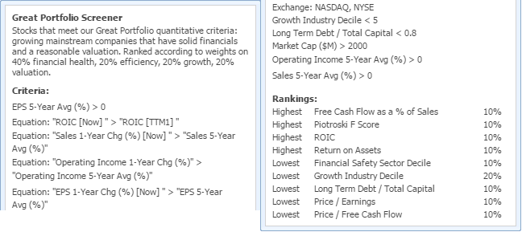

Paring Down the List

In the Table:
- Save as a watchlist
- Apply screener ranking to watchlist
- Group by sector
- Compare in views
- Open historical data to look for trends in the data

Other actions: Export for offline number-crunching, add column or create a custom view, filter, sort

In the Chart:
- Link to Table and run through charts vs. industry, sector, and S&P500
- Set ticker as a baseline for relative performance
- Chart a subset from the watchlist together to compare performance

Other chart options: add events such as max drawdown and splits, use technicals to assess momentum, chart fundamentals for a visual story on financials, shortcuts for instant chart configuration, candlesticks, dividend-adjusted price

In the Insight Panel:
- Summary – what is this company?
- Homepage – the company’s front door
- Grades – a quick take on profitability, growth, and financial health according to Morningstar’s strict criteria
- Short interest – is it in a normal range?
- Sales & EPS, growth – is the company growing earnings?
- Analyst ratings and estimates – how do analysts feel about it? are estimates being revised up or down?
- News – any significant headlines?
- Peers – where does the company fall compared to its peers in valuation, market cap, returns, and any other metric you want to see?

Other Insight Panel resources: company filings, earnings transcripts, outside links, statements, customize Peers tab, load peers in the main table

Other Tools:
- Research tickers (Quotes Box) – add in a ticker for comparison to the current list
- Alerts – set alerts on individual stocks or whole watchlists/portfolios
- Comments, notes, tags, and coloring for annotation and cataloguing
- Correlation (last tab of Portfolio Analysis) – see how a new pick correlates with your current portfolio
- Library – import sample screeners and more, share your own watchlists and screeners

