March Midness: A Mid Cap Stock Tournament
  - 3-31-15 Webinar Notes

See the companion blog series: https://www.stockrover.com/blog-march-midness-intro.html

Why mid cap?
Mid cap stocks (stocks generally between $2B - $10B market cap) often represent an optimal investing niche for long-term investors. In general they are larger, more proven, and therefore less risky than small cap stocks, while still being small enough to have significant growth potential.

To illustrate, compare the performance of this mid cap watchlist (consisting of four mid cap ETFs: RWK, VO, VOE, and VOT) to the S&P 500 over the past 10 years:

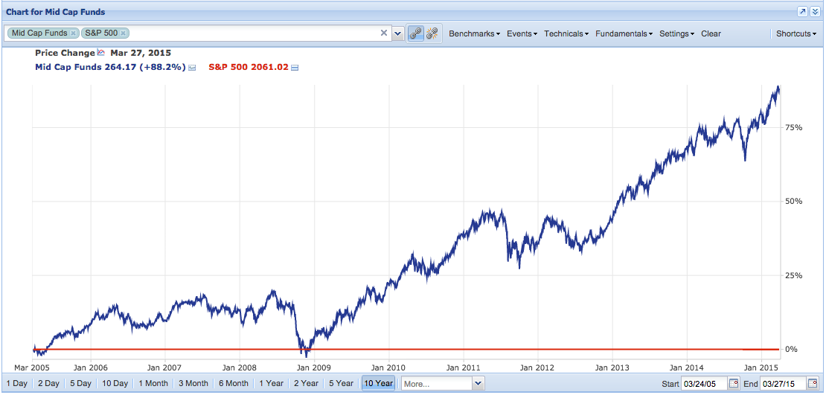

The mid cap watchlist is in blue, the S&P 500 is in red and set as a baseline. The mid caps watchlist, where each of the four ETFs are equal weighted in terms of initial investment, are up about 88%.

Disclaimer: The process outlined in this webinar and blog series is meant to offer a sound and repeatable process for analyzing potential long-term investments. However, it is not a completely comprehensive assessment and, as with any investment research process, it does not guarantee positive results. Always do research to your own satisfaction before investing your own money.

Finding 32 Competitors
To find the 32 stocks that would compete in the March Midness tournament, we created and ran a quant screener (https://www.stockrover.com/help-how-to-screeners.html#quantScreener) to rank the top 32 stocks according to the following weighted criteria:

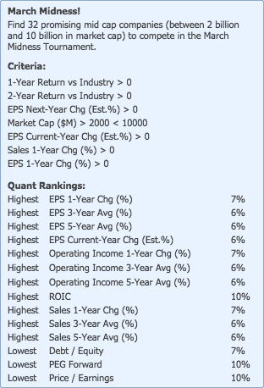

The ranking of the stocks gave us the seeding for the tournament (i.e., the #1-ranked stock faced the #32-ranked stock in the first round, and so on). The original bracket looked like this:



Download a blank bracket at: https://www.stockrover.com/library/pdf/march-midness-bracket-blank.pdf

First Round: Growth
  - Which company demonstrates better earnings growth?

Earnings growth is the hallmark measure of company growth. It answers the simple question of whether or not the company is making more money from year to year, which indicates that the company’s products or services are in demand.

Metrics to look at:
- Earnings per share (EPS) growth
- Sales growth
- Operating income growth

The following quant screener was used to score the stocks in the March Midness watchlist (right-click quant screener and select “Apply Quant to Watchlist”):

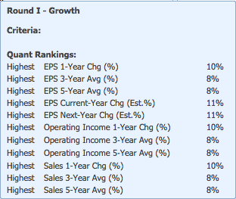

This quant is available for download to Premium subscribers in the Stock Rover Library. It can be applied to any watchlist or portfolio to score and rank the stocks in that population for growth.

Round II: Financial Health
  - Which company is financially healthier?

We want to make sure companies are not diluting their shares*, are able to meet their short- and long-term financial obligations, have a safe level of debt, and have increasing cash flow and free cash flow (which is cash flow minus capital expenditures). Cash flows are indicators of solvency as well as growth potential (i.e. if the company can invest cash back into its business to grow). Moreover, cash is not easily manipulated on a balance sheet, so it’s an indicator you can hang your hat on.

Metrics to look at:
- Financial health grade (given by Morningstar)
- Share count over time
- Debt/equity (current)
- Debt/equity over time
- Current ratio (current assets/ current liabilities; generally want this to be 2 or above)
- Quick ratio (current assets minus inventory/ current liabilities; generally want this to be 1 or above)
- Cash flow over time
- Free cash flow over time

The above columns were added to a custom table view in Stock Rover (https://www.stockrover.com/help-how-to-views.html#createView), and then each row was expanded (by clicking the triangle to the left of the ticker column) in order to get historical data and identify trends over time.

*Share dilution is not always a red flag, but it’s not something we are looking for or can trust at this stage. Read more about it here: http://www.investopedia.com/articles/stocks/11/dangers-of-stock-dilution.asp. On the other hand, a decreasing share count is almost always a good thing—it indicates that companies are buying back its own shares, investing in itself and increasing the value of outstanding shares.

Round III: Efficiency
  - Which company has more efficient operations?

Efficiency and profitability are closely linked. To determine efficiency, we look at profitability (margins and return on investment) metrics over time. Not only do we want companies that are growing in a healthy manner, as established in rounds I and II, but we want to see that the companies are getting increasing returns on that growth, augmenting profitability. Getting more bang for the buck, so to speak.

Metrics to look at:
- Profitability grade (given by Morningstar)
- Operating margin over time
- Return on assets (ROA) over time
- Return on equity (ROE) over time
- Return on invested capital (ROIC) over time
- Receivables % (receivables as a percentage of assets) over time

ROA, ROE, and ROIC often point in the same direction, but it’s still helpful to look at each one. ROA indicates how well a company is able to generate earnings from its assets. ROE measures net income as a percentage of shareholder’s equity (total assets minus total liabilities). ROIC is net income (less dividends) divided by total capital (which is total equity plus short- and long-term debt and capital lease obligations), and it indicates how well a company is able to generate returns using its capital. Note that, of the three, ROIC is most comparable across industries. Here, we are only comparing the trends across industries, not the values. In all cases, an increasing trend is desirable, as it indicates the company is getting more efficient at using its assets, equity, and capital.

Operating margin is operating income as a percentage of net sales. As with the ROA, ROE, and ROIC, we want to see an increasing trend in operating margin, as it indicates that over time a company is learning how to extract more usable income from each sale.

On the other hand, a decreasing trend is desirable for receivables %, as it demonstrates that the company is collecting more of what it is owed. A company with high percentage of receivables may be a leading indicator for a sales problem or an overly aggressive sales force. This raises the concern that some of the sales may be more forced and have a higher likelihood of not actually being collectable.

In Stock Rover, these metrics were displayed in the chart (found in Fundamentals menu) over a 5 year period, expressing the trend visually. The metrics were also added to a custom view in the table, with rows expanded to show historical data, in order to more closely examine trends that were not obvious from the chart.

Tip: Try the Efficiency metric package in the chart to see ROA, ROE, and ROIC charted together for any given stock. You can also create your own metric package with any set of fundamentals.

Round IV: Peer Context & Competitive Advantage
  - Which company is better positioned within its industry?

So far we’ve ensured that companies are growing in a financially responsible way, and getting smarter about how to increase their profitability. Now we want to place them in their industry and sector context, to see if their profitability is keeping pace with or exceeding that of their peers. The industry unit is not perfect, as there is still a lot of variability within industries, but it still speaks volumes as a benchmark.

Metrics to look at:
- EBITDA margin vs. industry average
- Gross margin vs. industry average
- Net margin vs. industry average
- Operating margin vs. industry average
- ROA vs. industry average
- ROE vs. industry average
- ROA vs. sector average
- ROE vs. sector average
- Growth industry decile
- Profitability industry decile
- Growth sector decile
- Profitability sector decile

The first eight metrics above each represent a company’s profitability versus that of its industry (or sector) average. We want to see positive numbers in all cases, as it means that the company is outperforming its industry or sector in profitability metrics. The last four metrics place the stock in its respective industry and sector deciles for growth and profitability. A lower decile is better (i.e. a decile of 1 means that the stock is in the top 10%).

In addition to quantitative excellence, we also want to gain a qualitative understanding of the company’s angle on the market. We constructed a brief profile using these questions:

- What is the main service or product the company provides?
- What secondary services or products does the company provide?
- What countries/continents does the company mainly serve?
- Who are the company’s direct competitors?
- What are the primary risks to the company’s profitability?
- How does the company protect its product or service from these risks?
- Any other items of interest?

Answers to these questions can be found via links in Stock Rover’s Insight panel. Look for the company’s SEC filings (Summary tab), news items about the company (News tab), and any research articles or analyst reports about the company (Links tab—this list of links is customizable). The more you are able to understand a company’s structure and context, the better you will be able to assess the business.

Final Round: Valuation and Risk
  - Which stock is more likely to provide the best risk-adjusted return?

If a company has passed all the previous tests, you probably have a good one on your hands, at least from a fundamental perspective. We now want to assess the stock’s pricing and level of risk.

Valuation metrics to look at (used in quant below, at left):
- EV / EBITDA
- Price / earnings (P/E)
- Price / earnings industry decile
- Price / sales (P/S)
- Price / book (P/B
- PEG Forward

We are looking for lower numbers in all of the above. Lower multiples mean that the stock price is relatively cheap considering the company’s earnings, sales, and book value. PEG forward incorporates expected EPS growth as a way to adjust valuation for growth (a PEG forward of 1 theoretically suggests perfect pricing). EV / EBITDA is similar to P/E and is better for comparing across industries, as it levels the effect that capital structure can have on earnings.

Risk/volatility metrics to look at (used in quant below, at right):
- Max drawdown over 2 years
- Beta 1-year
- Beta 3-year
- Volatility 1-year
- Volatility 3-year
- Risk-adjusted return over 2 years

In the risk and volatility metrics, we are seeking less risky stocks (lower volatility, but still with strong performance). By conventional wisdom low-risk stocks have less potential for return, but that is not necessarily the case. Our goal is to pick stocks that maximize return while looking to minimizing risk. The risk-adjusted return metric is only available for Premium users. It can be found in the Portfolio Reporting window (http://www.stockrover.com/help-how-to-reporting.html) or in Portfolio Modeling (http://www.stockrover.com/quick-guide-modeling.html).

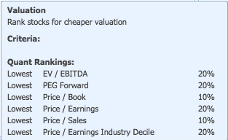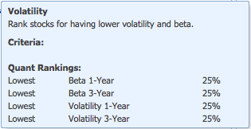

A Few More Handy Tricks in Stock Rover

Whether you are running a tournament or not, these tricks will help you compare and organize stocks:

- Group table rows to see how a dataset breaks down by category
  - http://www.stockrover.com/help-how-to-table.html#groupData

- Color a row to categorize and keep track; also group by color
  - http://www.stockrover.com/help-how-to-table.html#colorRow

- Tag a row to categorize and keep track; also group by tag
  - http://www.stockrover.com/help-how-to-table.html#tagTicker

- Hide a row to clear it from view or see how a group of tickers performs without it
  - Right-click a row and select “Hide Row” (use Filter menu to restore the row)

- “Explain” in the column drop-down menu for a definition and benchmark values
  - http://www.stockrover.com/help-how-to-table.html#colInfo

- Chart dividend-adjusted price to understand a stock’s total return
  - http://www.stockrover.com/help-how-to-charting.html#dividendAdjusted

- Chart a screener to see how the passing stocks have historically performed
  - Right-click a screener in the Navigation panel and select chart

