How to Write Custom Metrics

Contents

Introduction

Functions

Examples

Historical Time Periods

Tips

Troubleshooting

Introduction
The Custom Metric facility allows you to create new metrics from existing Stock Rover metrics. The metric can then be used as filters in screeners as custom equation screeners or they can be added to Table Views as individual columns.
The capabilities of custom metrics range from creating a simple ratio of two existing metrics, to comparing the same metric over different time periods, to creating a brand-new formula with whatever level of complexity is needed to achieve the desired result.
This guide will explain custom metric writing in the following five sections: Functions, Examples, Historical Time Periods, Tips and Troubleshooting.

Functions
Functions can be used when creating custom metrics or creating equation screeners. Below is a list of the available functions along with their descriptions.
**Note: The functions are case sensitive and must be written in lower case
abs | Returns the absolute value of value
and | Boolean function combines tests and checks for both tests to be true
case when then else end | This function lets you evaluate conditions and return a value when the first condition is met (like an IF-THEN-ELSE statement)
greatest | Selects the greatest of a set of values
ifnull | Returns the second value if the first value is null.
is null AND is not null | Tests to see if the value is null or not null.
least | Selects the least of a set of values
nullif | Returns null if the first and second are equal otherwise it returns the first value.
or | Boolean function combines tests and checks for either test to be true
pow | Returns the value raised to the nth power

Examples
Listed below are a practical example for each function. It will indicate if the example is a Custom Metric example or an Equation Screener example.
Abs
Description: This custom metric shows one-year return as a percent of the Max Drawdown over 5 years

Formula:
100 * "1-Year Return [Now] " / abs( "Max Drawdown 5-Year" )

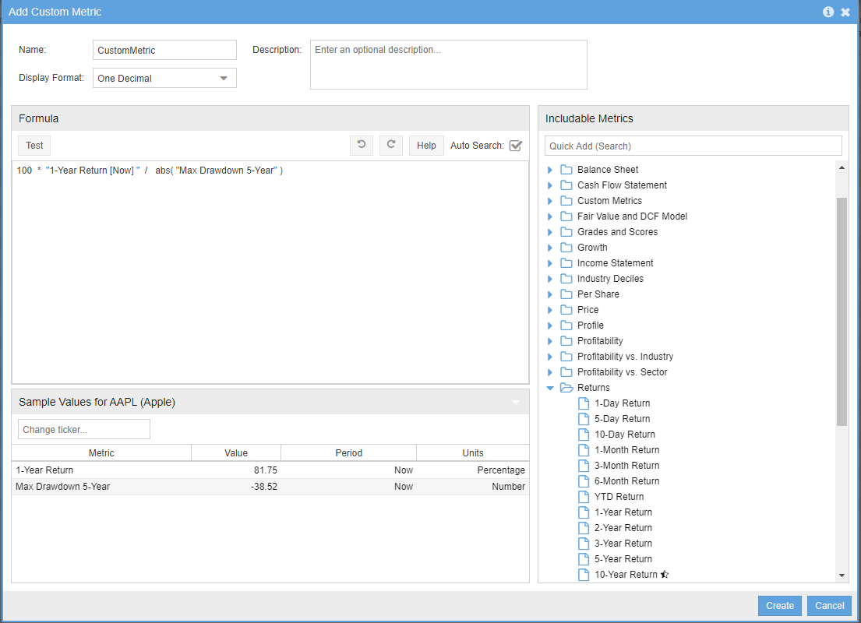

and
Description: This equation example shows one-year return as a percent of the Max Drawdown over 5 years

Formula:
"Altman Z-Score [Now] " > 1 and "Altman Z-Score [Now] " > "Altman Z-Score [TTM1]"

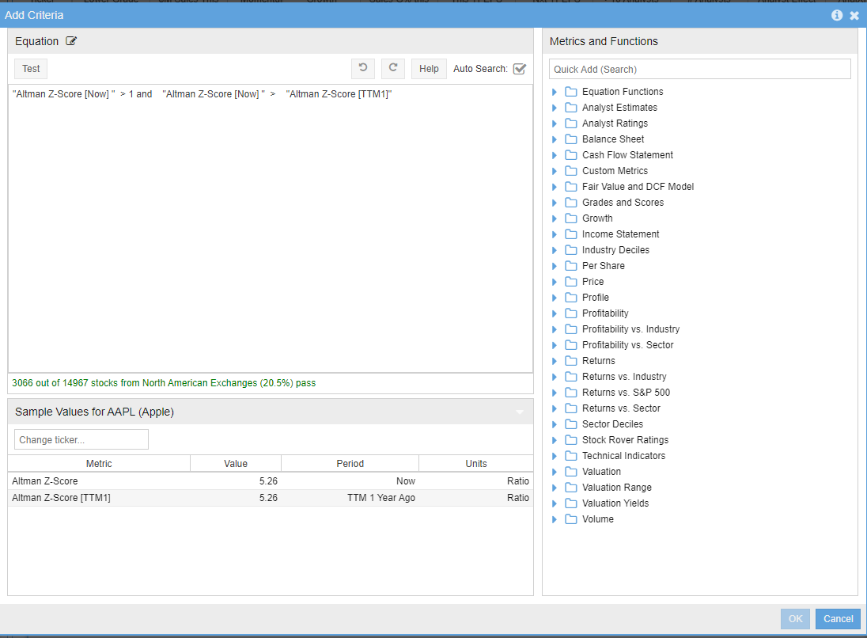

case when then else end
Description: This custom metric shows Net Cash as % of share price and excludes negative values

Formula:
100 * case when "Net Cash Per Share [Now]" < 0 then null else "Net Cash Per Share [Now]" / "Price [Now]" end

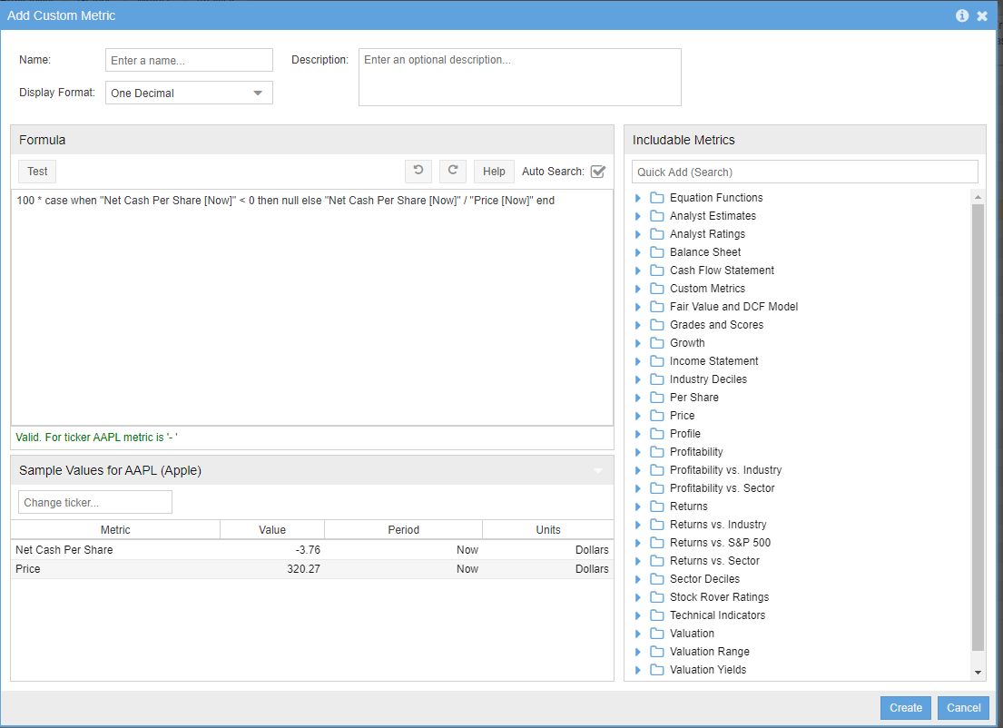

greatest
Description: This custom metric shows the best yearly return vs. the market in the past 3 years

Formula:
greatest ( "1-Year Return vs S&P 500 [Y1]" , "1-Year Return vs S&P 500 [Y2]", "1-Year Return vs S&P 500 [Y3]" )

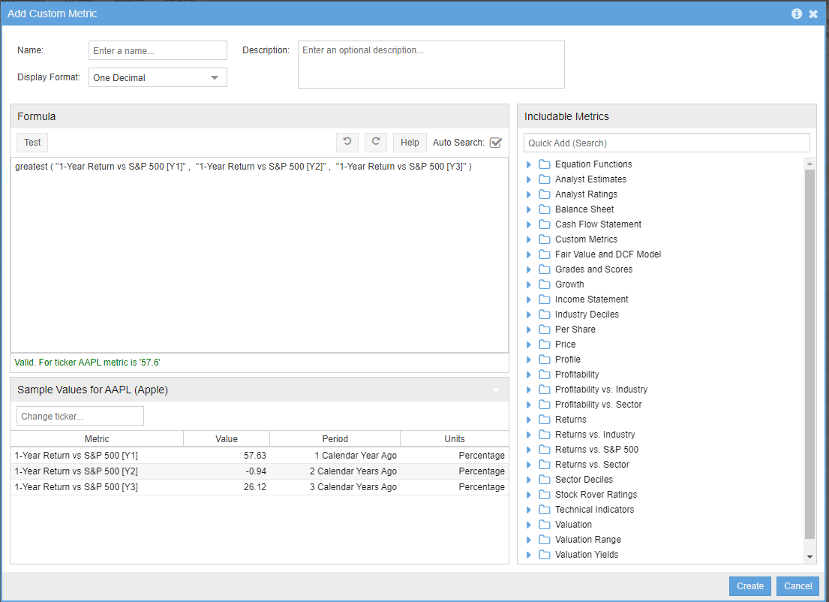

ifnull
Description: This example find companies that have good long-term returns but have not existed for a long time:

Formula:
ifnull("Annualized 10-Year Return", "Annualized 3-Year Return") > 10

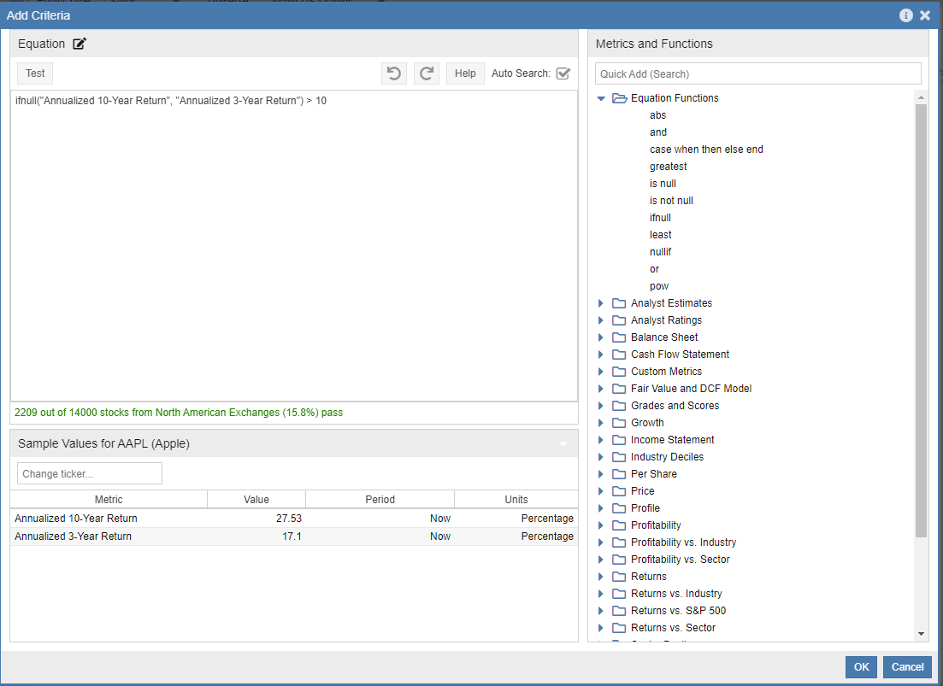

is null AND is not null
Description: This equation example finds stocks that recently stopped paying dividends entirely

Formula:
"Dividend Per Share [Now]" is null and "Dividend Per Share [TTM1]" is not null

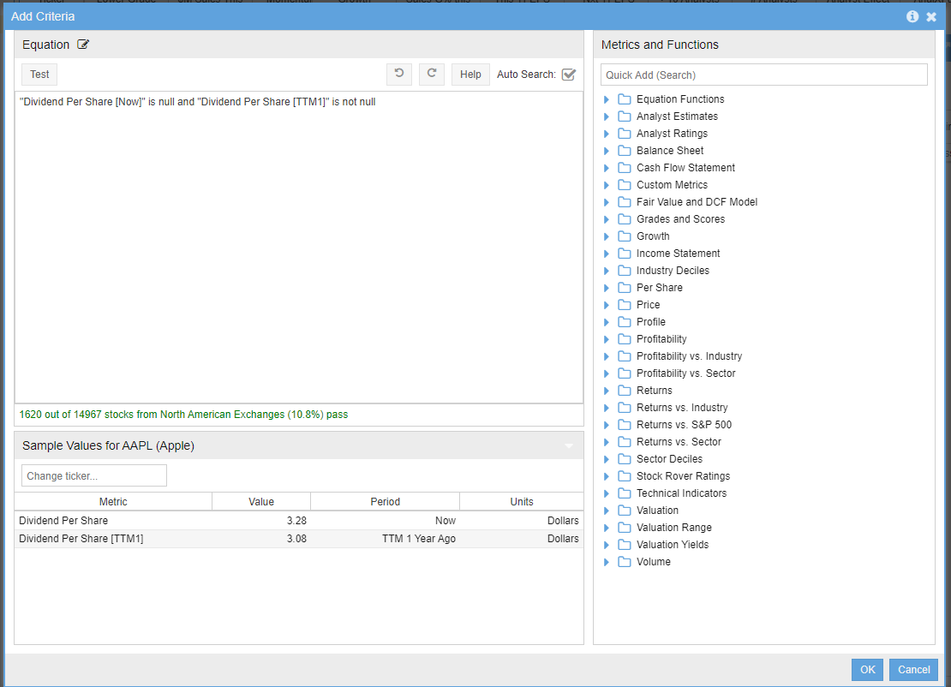

least
Description: This equation example finds stocks that underperformed the market by at least 35% during a recent calendar year

Formula:
least ( "1-Year Return vs S&P 500 [Y1]" , "1-Year Return vs S&P 500 [Y2]" , "1-Year Return vs S&P 500 [Y3]" ) < 35

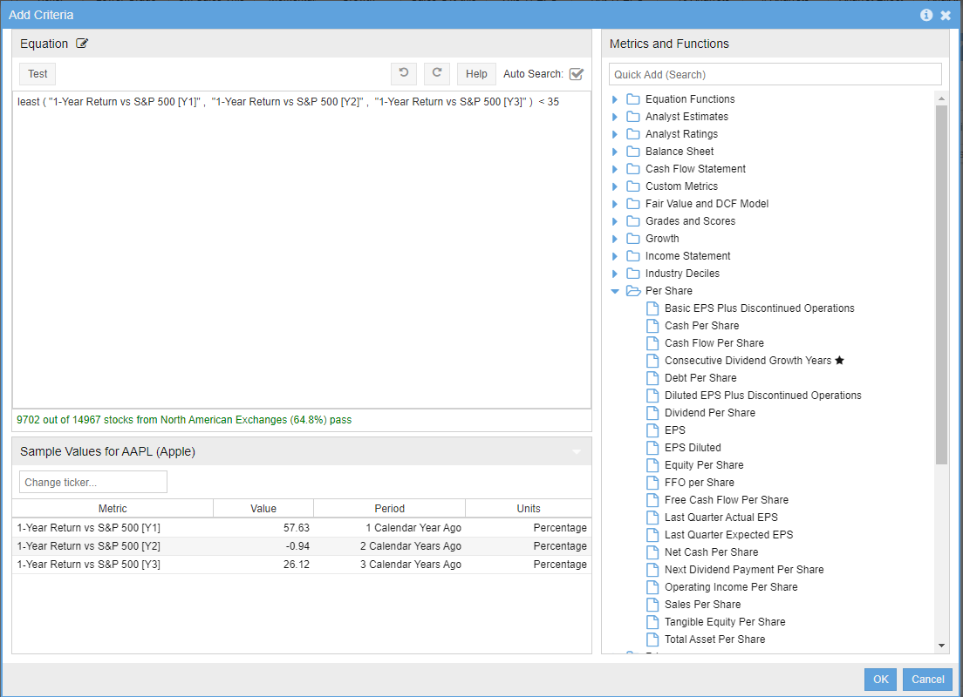

nullif
Description: This equation uses nullif within a custom metric that computes an effective interest rate on the company’s debt, where the nullif ensures we are looking only at companies with debt

Formula:
100 * "Interest Expense [Now]" / nullif("Total Debt [Now]", 0)

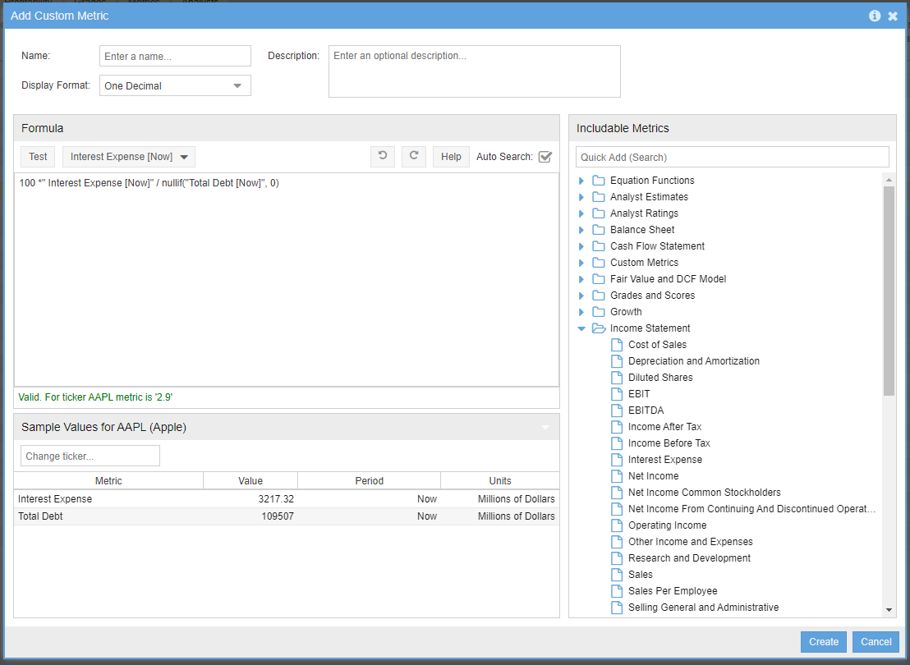

or
Description: This equation finds stocks with extremely low valuation ratios based on either Price to Earnings or Price to Book

Formula:
("Price / Earnings [Now]" < 4 and "Price / Earnings [Now]” > 0) or ("Price / Book [Now]" < .5 and "Price / Book [Now] " > 0)

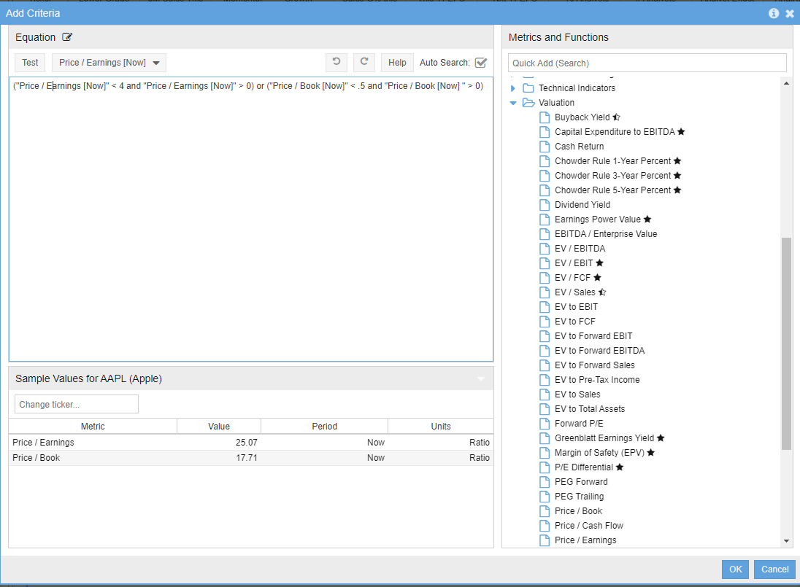

pow
Description: This custom metric computes a 5-year growth rate of Sales Per Employee

Formula:
100 * (pow( case when "Sales Per Employee USD [Now]" / "Sales Per Employee USD [TTM5]" <= 0 then null else "Sales Per Employee USD [Now]" / "Sales Per Employee USD [TTM5]" end , 1/5 ) - 1)

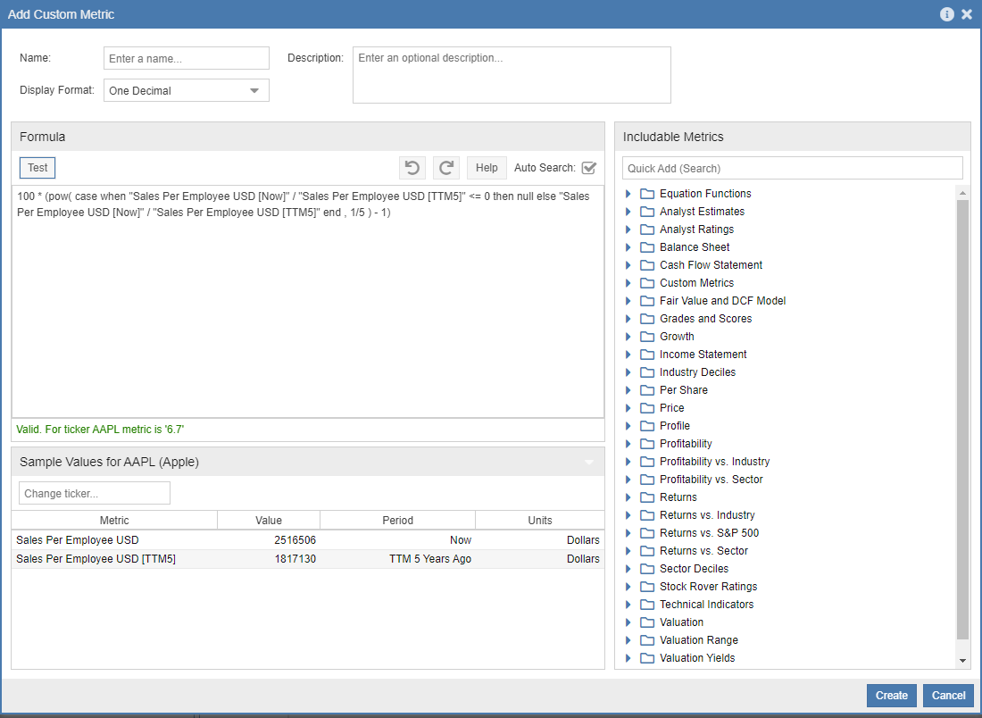

Historical Time Periods
In both Custom Metrics and Equations screeners you can access historical data for the metrics that support historical data.
In the screenshot below you can see the highlighted box on how to access the historical time periods.
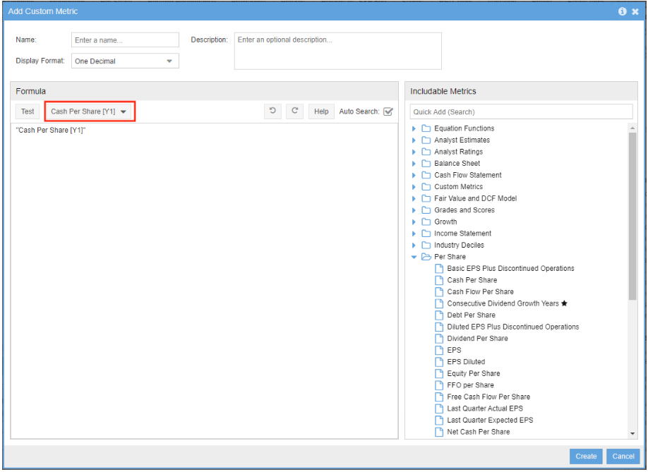

Below is a screenshot of the window that appears when you click on the box highlighted from the above screenshot.
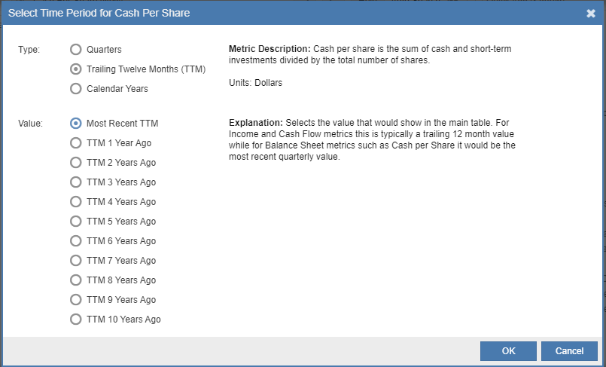
Here is what each time period represents:
  - Now: The value that would show in the main table, this is normally the trailing 12-month value

  - Most Recent Quarter (MRQ): Uses the most recent quarterly result

  - TTM X Years Ago: Uses the trailing twelve months of data, but for prior years rather than the current trailing twelve months

  - X Calendar Years Ago: Looks at results for individual calendar years

  - X Quarters Ago: Looks back X quarters
For example, EPS is shown in the main table as a trailing 12 month value so "EPS [Now]” is equal to "EPS [MRQ]" + "EPS [Q1]" + "EPS [Q2]" + "EPS [Q3]"

Tips
Tip: Make sure to always test the metric or equation to see if the formula is valid
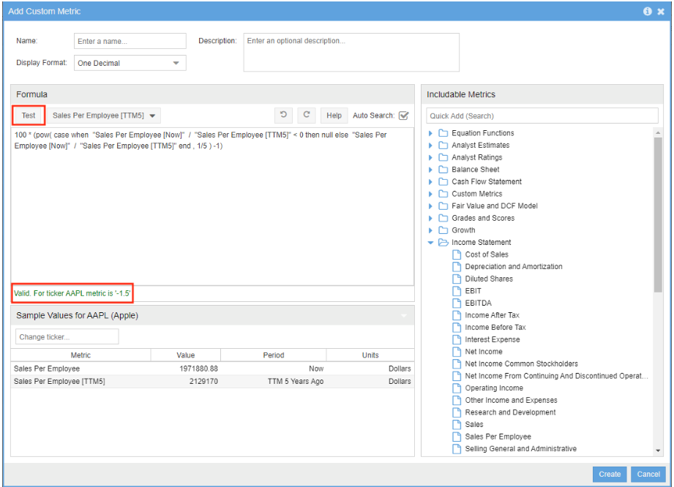

Tip: It is very important to use parentheses in the equations or custom metrics to make sure the order of operations is done correctly
Example:
"FFO per Share [Now]" * "Diluted Shares [Now]" / "Equity [Now]"+ "Accumulated Depreciation [Now]"
Returns -284.2 for a particular ticker, but if you add parentheses…
( "FFO per Share [Now]" * "Diluted Shares [Now]") /( "Equity [Now]"+ "Accumulated Depreciation [Now]")
Returns 0.5 for the same ticker
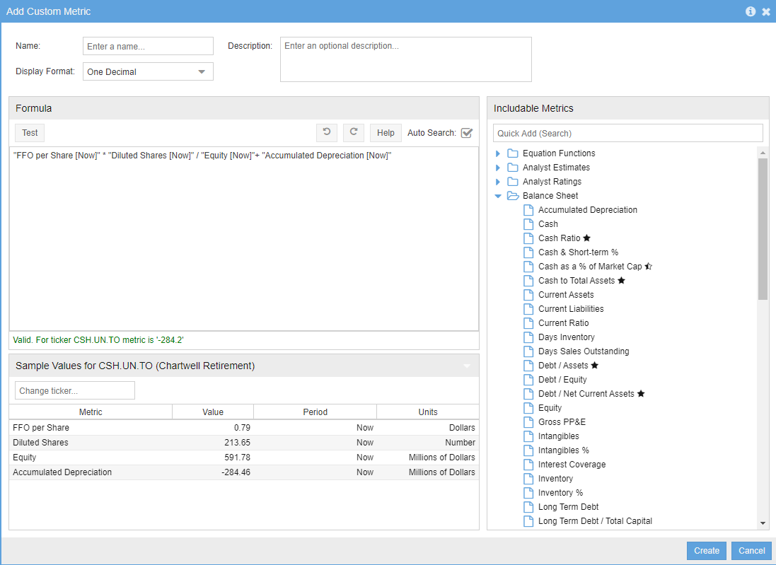

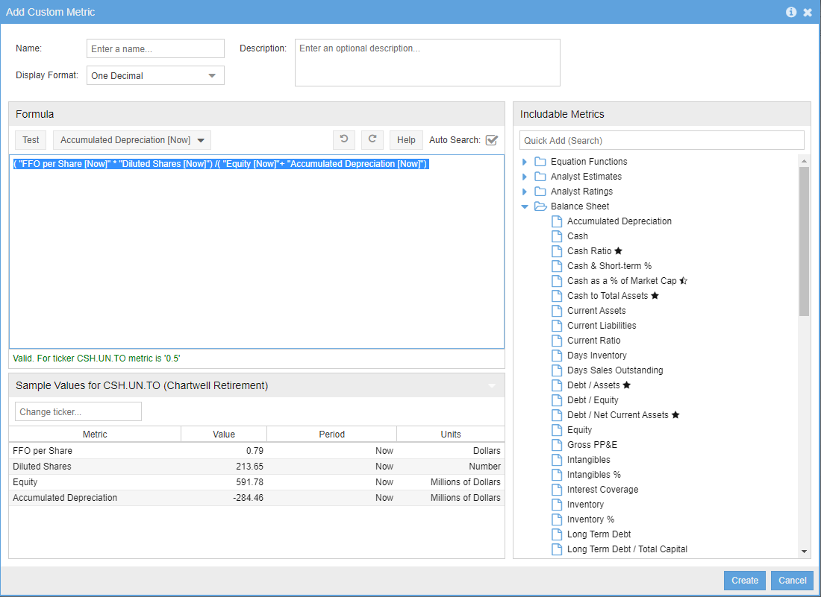

Troubleshooting

  - If you copy a formula from a document or email to the formula window and then the test fails, make sure to retype the quotes. Sometimes the quotes get copied in the wrong format.
  - If you are using the pow function for a custom metric and you add it to a view, and then you start getting an error Server not responding, then you need to edit the function and add the case statement because the pow function only accepts positive numbers.
The pow function should have the case when statement around it like this:
100 * (pow(case when "EPS [Now]" / "EPS [Y5]" <= 0 then null else "EPS [Now]" / "EPS [Y5]" end, 1/5) - 1)
  - If you test a custom metric that is looking at historical values and the data doesn’t return, this could be because of the following:
- The ticker is a foreign company, they don’t typically have quarterly data
- Companies with a Market Cap of less than $10 million won’t have quarterly data

