Weekly Portfolio Check
  - A Presentation to the Boston Investors’ Group
  - 7:00pm, February 24, 2016

  - Howard Reisman, CEO and Co-founder Stock Rover
  - howard.reisman@stockrover.com

Presentation Goals
- Demonstrate a quick weekly check to see if anything significant has changed in any position to cause a rethink of that position. It should take on the order of 10 minutes to complete.
- The goal is to flag holdings where issues may be developing that require additional investigation.

Three Sample Portfolios – Each of Which Runs a Different Strategy
- Growth Portfolio of 14 stocks selected for capital appreciation potential
- Income Portfolio of 14 stocks designed for current income and growing future income
- Stability Portfolio of 4 ETFs designed to generate return with less risk (volatility)

For Each Portfolio…
- Check overall portfolio performance
  - Absolute performance
  - Performance vs. the market
  - Risk adjusted performance vs. the market
  - Review holdings that have had most positive and most negative impacts on the overall portfolio, based on its performance and its weight in the portfolio, as these stocks are the most likely candidates for capital adjustment. Flag any concerns for additional research.
- Examine the capital allocation of each stock in the portfolio to ensure it is within bounds
  - Ensure that hasn’t become a too big a part of your portfolio
  - Too much single stock risk can be a major undoing of an otherwise solid portfolio
  - Conversely if a position is too small, consider either increasing or exiting

For Each Stock in Each Portfolio…
- Check each stock’s relative performance and note anything of concern
  - Use a 1 year chart vs. its industry and vs. the S&P 500 (flatline the industry)
- Check each stock’s technicals via the chart and note anything of concern
  - Use a 1 year chart with 50 and 150 day SMA technicals
- Check each stock for significant analyst estimate changes
  - Continual revisions downward are normally not a good sign as more usually follow

Growth Portfolio
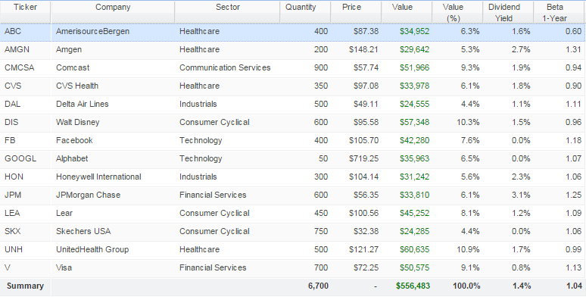

Income Portfolio
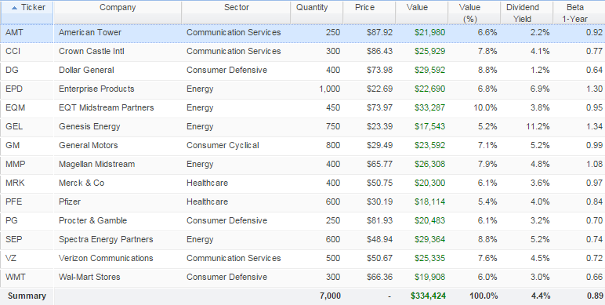

Stability Portfolio
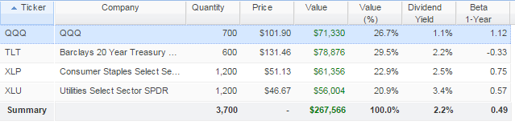

Portfolio Level Checks

Overall Portfolio Performance (3 Month Chart)
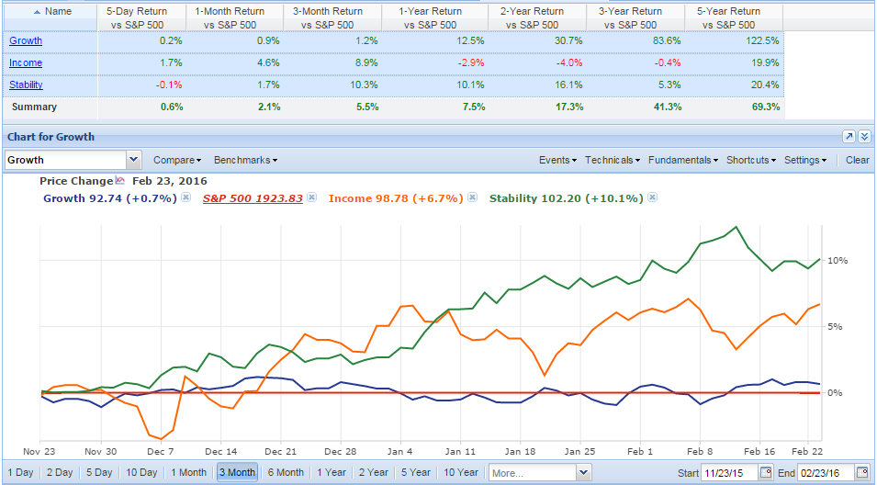

Risk Adjusted Portfolio Performance (1 Month)
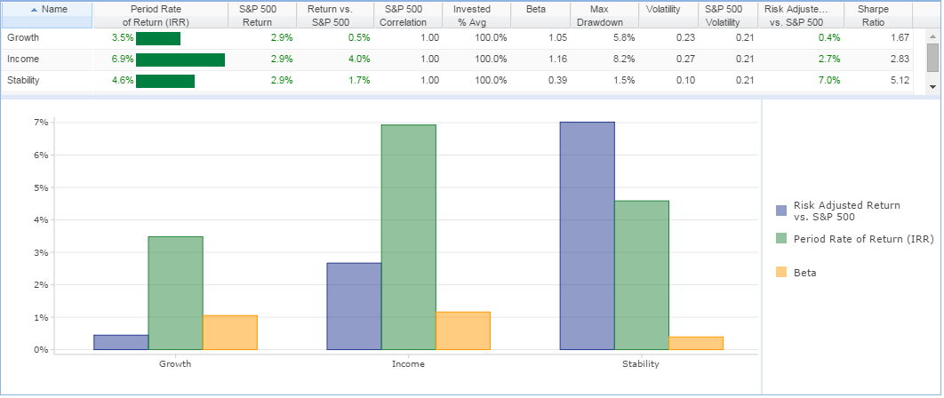

Holdings with Most Impact on Performance (1 Month) – Growth Portfolio
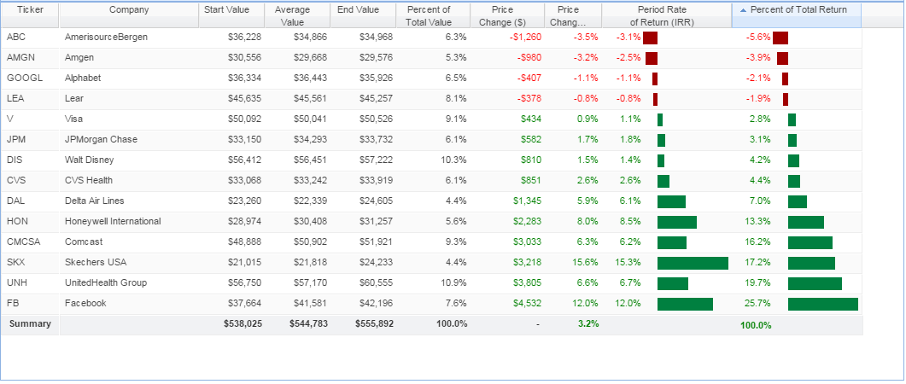

Portfolio Balance - Stock Rover Rebalancing Tool – Stability Portfolio
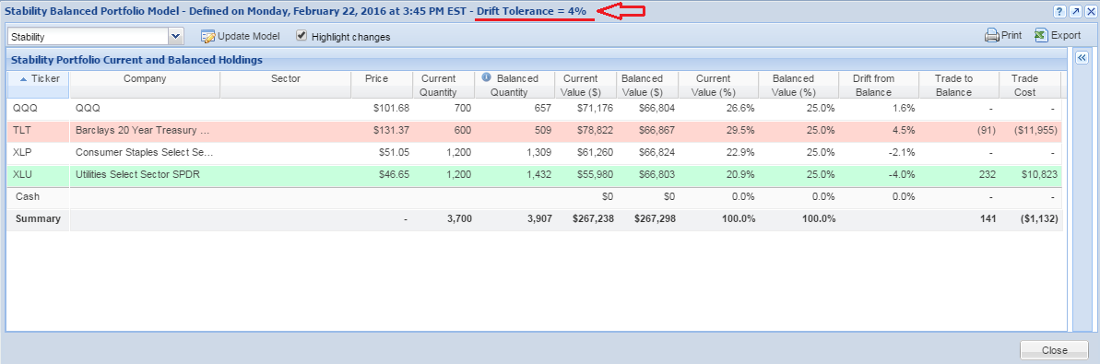

Stock Level Checks

Stock Performance Relative to S&P 500 and Industry (baselined) – AmerisourceBergen (ABC)
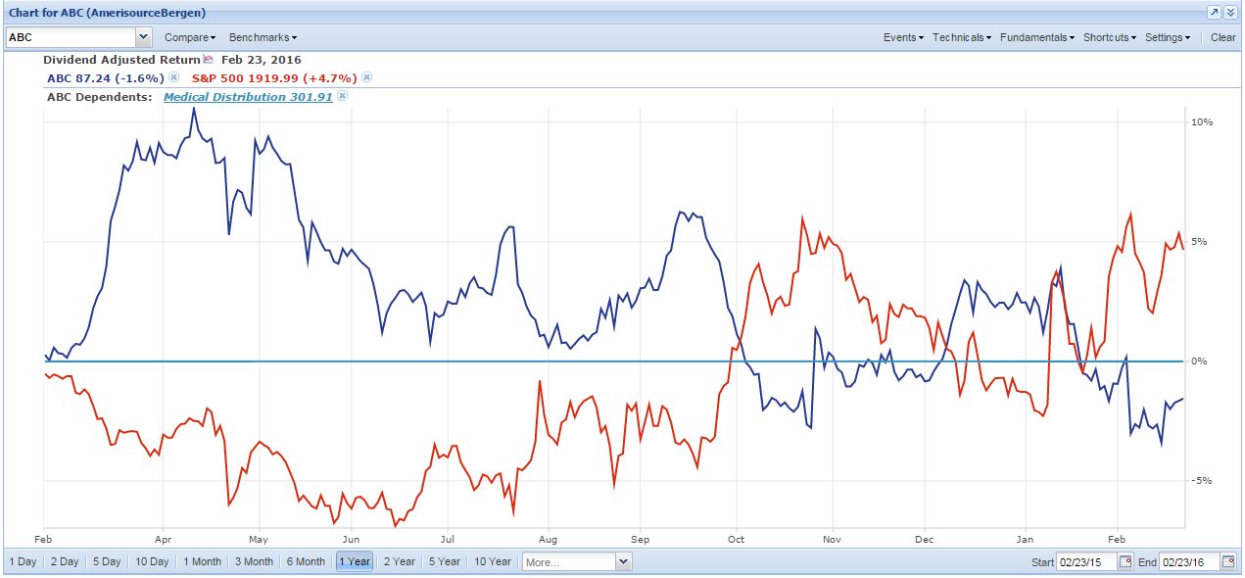

Stock Technicals with Simple Moving Average – AmerisourceBergen (ABC)
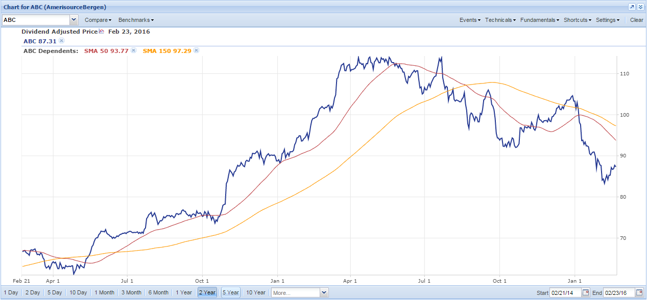

Analyst Estimates Change – Stock Rover Insight Panel – Analyst Tab – AmerisourceBergen (ABC)
