Side-by-Side Stock Comparison Outline
Overview
- Webinar goals
- Choosing the industry/sector
- Efficiency and Management Screener
- Valuation and Growth Screener
Webinar Goals
The goals of this webinar are to illustrate how to use SR to analyze stocks side by side, and at the same time determine which stock between Comcast and Dish is a better pick.
Picking an industry/sector
Comcast and Dish are in the Pay TV industry and Communication Services Sector. I discussed the industry in this article last week. Generally, it is preferable to invest in a booming industry/sector and not one that is underperforming the economy. We’ll use the charting tool to show:
- Industry performance
- Sector performance
- S&P 500.
But there are exceptions to the rule i.e. one, the stock you are picking is in a changing market and you think it is better positioned to take advantage or benefit from the change, and two; the stock has wide economic moat. To see what economic moat looks like in SR, we will:
- Use Industry Vs. Sector Vs S&P 500 view
- Use historical return metrics
Efficiency and Management Screener
The efficiency and management screener will show us which company is more efficient and has better management, at least according to quantitative factors. Under efficiency, our goal is find out which company is more efficient at running its business (operational efficiency) and which is a better employer of capital (capital efficiency). Under management, we will attempt to gauge which company has better management i.e. which management’s interests are better aligned with those of shareholders. The screener will be equally weighted between efficiency and management metrics.
Weight Distribution
Efficiency Metrics | 50%
Management Metrics | 50%
Total | 100%

Screener details are shown below:

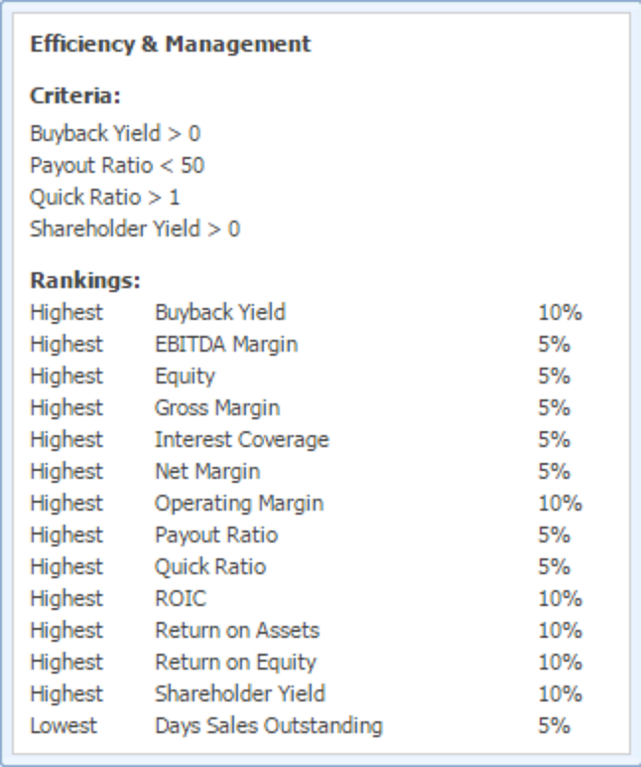
We will use this screener ranking and table metrics to analyze operational and capital efficiency metrics and charts to show trends over time.

Valuation and Growth Screener
Similar to the Efficiency and Management screener, the Valuation and Growth screener will be equally weighted between valuation and growth metrics as shown below.
Weight Distribution
Valuation Metrics | 50%
Growth Metrics | 50%
Total | 100%

With this screener, our aim is to find out which company, between Dish and Comcast, is not only undervalued but also has significant growth potential. The specific weights of the individual metrics are shown below:
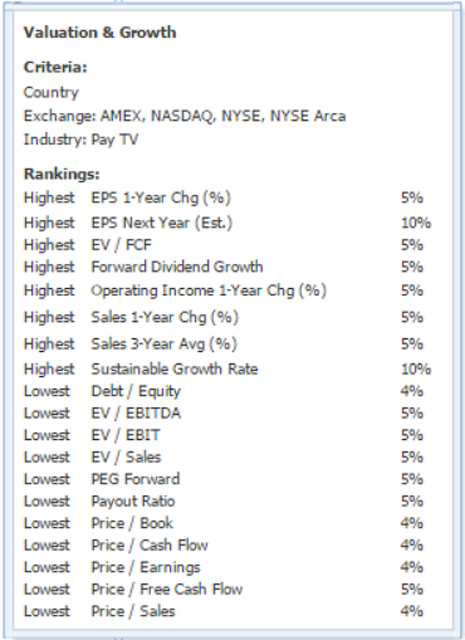
We will then use metric packages and charting to analyze valuation metrics.
Additional Resources
For more examples of comparison in Stock Rover and program tutorials, see:

- March Midness! A Mid Cap Stock Tournament (video and blog post)
- KORS vs. COH vs. KATE: The Battle of the Brands (blog post)
- Panera vs. Chipotle: Where Should an Investor Dine? (blog post)
- Stock Rover Help Pages
- Stock Rover Video Library

