Investing in Today's Market
Howard Reisman, November 6th, 2014

Two Key Questions for Investors
There are two key questions that should be on the mind of every investor
- Is now a good time to invest?
- If so, given today’s market environment, what makes sense to invest in?

First Question - Is Now a Good Time To Invest?
To try to ascertain if now is a good time to invest, we need to ask more questions. For example:
- Is the economy sound?
- Is the market expensive?
- Will interest rates stay low?
- If interest rates rise - what happens to the market? And what is good to own?
We will endeavor to shed some light on all of these questions.

Is the Economy Sound?
In considering if the economy is sound, we should start with recessions. Recessions are very bad for stocks and will destroy a lot of investor capital very quickly. So we should first answer the question - Is there a near term recession risk?

According to a study done by Omega Advisors (Leon Cooperman’s company), recession danger is signaled when some or all of these factors appear :
- The yield curve is inverted (short term interest rates exceed long term rates)
- Unemployment claims are rising
- Personal income is down
- Consumer confidence is falling
- Industrial production is declining
- Inventories are increasing

Let’s look at each of these indicators and see if any of them are giving us a warning signal now.

The Yield Curve
An inverted yield curve is bad because it means that investors and the Federal Reserve are fretting about inflation in the short term, and that investors are pessimistic about long-term growth and expect that the yields offered by long-term fixed income will continue to fall.
The yield curve is not inverted nor has it been since mid-2007. Currently the 10 year treasury is around 2.61% and the three month is around 3 basis points 0.03%, so long term rates exceed shot term rates.

Current Short and Long Term Yields
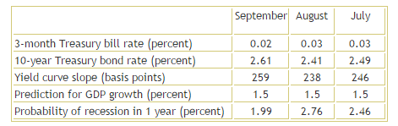

Source: Cleveland Federal Reserve

The following chart shows a chart of the probability of a recession based on the yield curve from 1960 to the present day. The likelihood of a recession based on the yield curve is currently minimal.
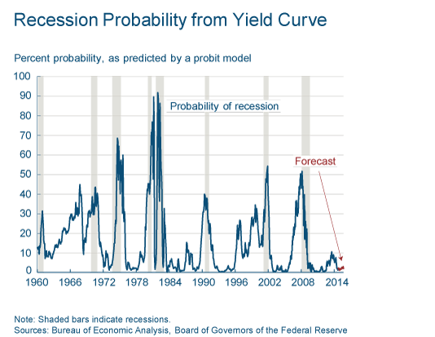

Unemployment Claims
A factor in predicting recessions is when unemployment claims are rising. The following chart shows the unemployment rate since 1990. It is pretty clear that starting in 2010, unemployment rates have been steadily falling.
The latest statistics show that the national unemployment rate dropped to 5.9 percent in September, according to the U.S. Bureau of Labor. That marks the first time unemployment has been below six percent since July 2008. Approximately 248,000 new jobs were created during September.

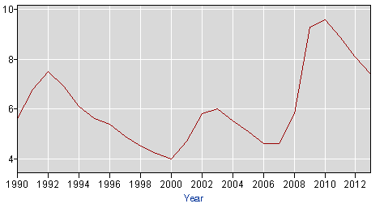

Source: U.S. Department of Labor

Personal Income
Last month, Personal income increased $22.7 billion, or 0.2 percent, and disposable personal income (DPI) increased $15.7 billion, or 0.1 percent, in September, according to the Bureau of Economic Analysis. It has increased every month thus far in 2014.

Source: U.S. Department of Commerce

Consumer Confidence
According to the Conference Board, which is the “go to” source for consumer confidence, October saw a rebound in consumer confidence. The text of their October 28th, 2014 release follows.
The Conference Board Consumer Confidence Index® Rebounds
The Conference Board Consumer Confidence Index®, which had decreased in September, rebounded in October. The Index now stands at 94.5 (1985=100), up from 89.0 in September. The Present Situation Index edged up from 93.0 to 93.7, while the Expectations Index increased sharply to 95.0 from 86.4 in September.
The monthly Consumer Confidence Survey®, based on a probability-design random sample, is conducted for The Conference Board by Nielsen, a leading global provider of information and analytics around what consumers buy and watch. The cutoff date for the preliminary results was October 16.
Says Lynn Franco, Director of Economic Indicators at The Conference Board: “Consumer confidence, which had declined in September, rebounded in October. A more favorable assessment of the current job market and business conditions contributed to the improvement in consumers’ view of the present situation. Looking ahead, consumers have regained confidence in the short-term outlook for the economy and labor market, and are more optimistic about their future earnings potential. With the holiday season around the corner, this boost in confidence should be a welcome sign for retailers.”
Source: The Conference Board

Industrial Production
The Gross Domestic Product (GDP) in the United States expanded at a seasonally adjusted annual rate of 3.50 percent in the third quarter of 2014 over the previous quarter. GDP Growth Rate in the United States averaged 3.27 Percent from 1947 until 2014, reaching an all-time high of 16.90 Percent in the first quarter of 1950 and a record low of -10 Percent in the first quarter of 1958. GDP Growth Rate in the United States is reported by the U.S. Bureau of Economic Analysis.

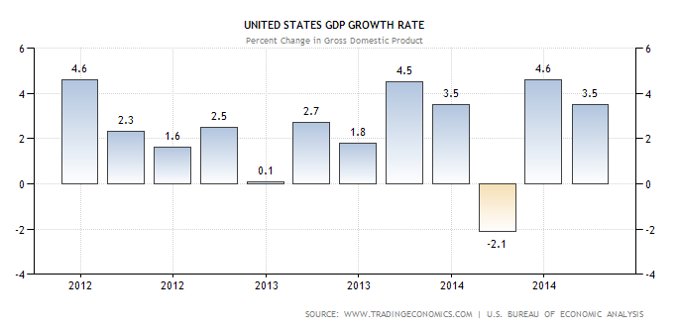
Source: U.S. Bureau of Economic Analysis

Inventories

U.S. showed a decrease in inventory in 2014 Q3
The United States economy advanced an annualized 3.5 percent in the third quarter of 2014, slowing from a 4.6 percent increase in the previous period. Advance estimates showed a downturn in inventory, residential and nonresidential investment and deceleration in personal consumption, exports and state and local public spending.
Source: Trading Economics

Summary
After examining six factors that help foreshadow recessions, we seen that none of them are flashing red. In fact the economy is currently in a solid stable growth mode and appears to be slowly improving. This is a good environment for long term investors.

Is the Market Expensive?
Whether the market is expensive is often determined by looking at the P/E of the S&P 500 relative to historical norms. Note that mid-caps as proxied by the Russell 2500 and Small caps as proxied by the Russell 2000 should also be considered to see if there are significant valuation differences between segments of the market (large cap, mid cap and small cap). Let’s start with the S&P 500 as it is the most commonly looked at indicator for determining the valuation of the market.

S&P 500 Historical P/E Ratio
The average S&P 500 P/E Ratio is normally around 15 to 16. Currently it is around 19, so by that measure, the P/E is a little higher than average.
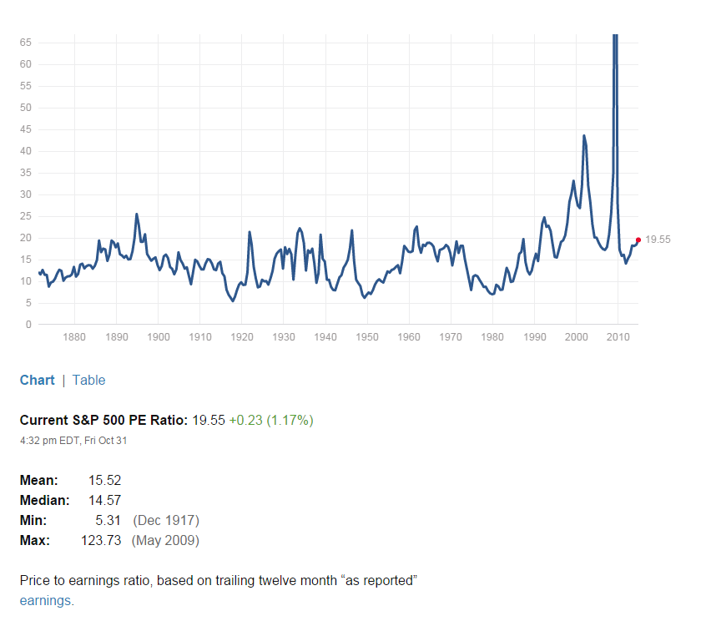
Source: multpl.com
Note that the reason the S&P P/E was so high in 2008 was because the “E” portions of the equation (earnings), plunged dramatically as can been seen in the chart below.
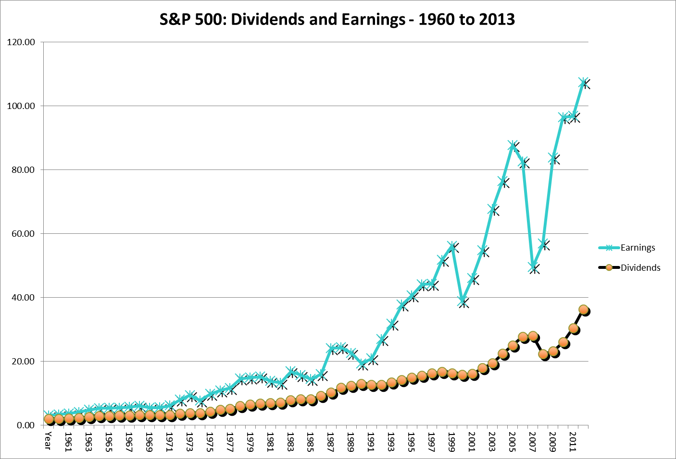
Source: NYU Stern Business School

Shiller P/E Ratio
If you a fan of Robert Shiller, the Yale university professor who helped create the CAPE ratio (cyclically adjusted price-earnings) which looks at the S&P 500 over the last 10 years, you will find thing less sanguine. The CAPE is quite expensive vs. historical norms with its current value over 26. One of the reasons the CAPE is so high is the last 10 years includes the exceptionally poor years of 2007 and 2008 (2006 and 2009 weren’t so hot either). So four of the last ten years were significantly below trendline earnings wise. So depending on how much of an anomaly you view those periods, will probably shape your views towards the value of this measure.
There is some more color on Shiller’s views in this blog entry
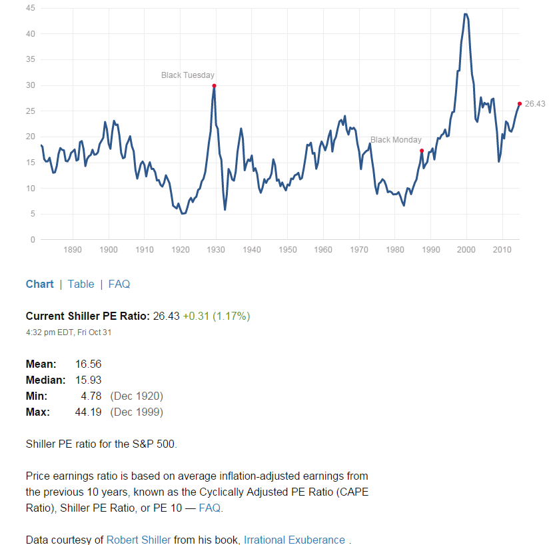
Source: multpl.com

S&P 500 Historical P/B Ratio
Let’s briefly look at other measures of the S&P 500 valuation to see if anything else is out of whack. Let’s start with the S&P 500 Price to Book ratio. We can see that P/B is just a tad above its 15 year median and mean values. So the P/B valuation looks reasonable by recent historical standards.
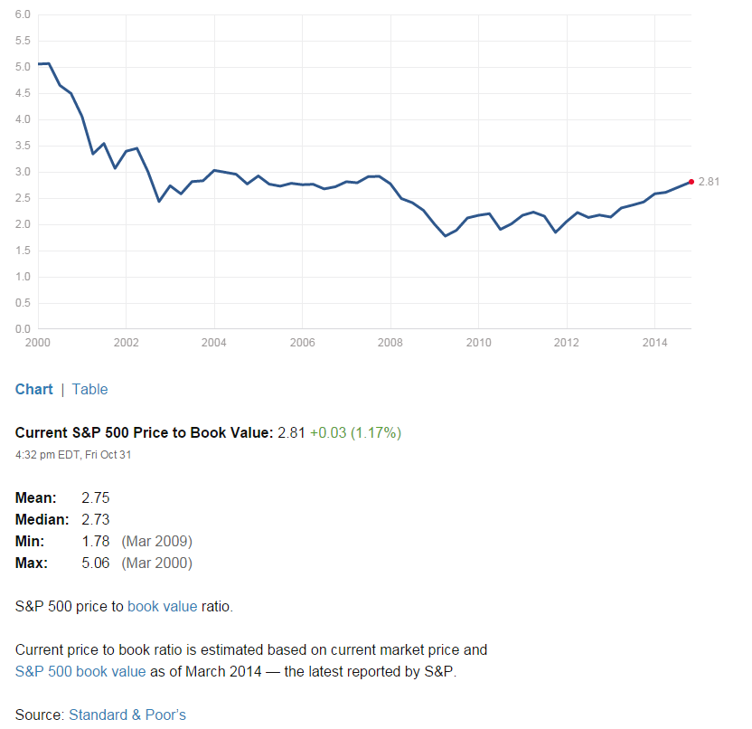
Source: multpl.com

S&P 500 Historical P/S Ratio
Let’s also check out S&P 500 Price to Sales ratio. We note that the measure is definitely in the upper end of its recent range.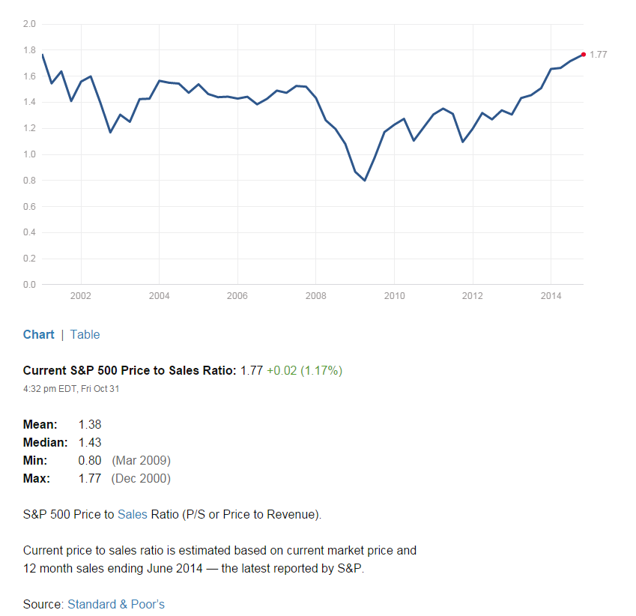
Source: multpl.com

Summary
Based on historical data, the S&P 500 is slightly expensive compared to historical norms. However interest rates are also historically low (see following chart). So risk premium of equities (earnings yield minus the “risk free” treasury yield) actually puts stocks in the fair value neighborhood. Unless you are a disciple of Shiller, the common view is stocks are roughly fairly valued, neither cheap or overly expensive.
10 Year Treasury Rate (source: multpl.com)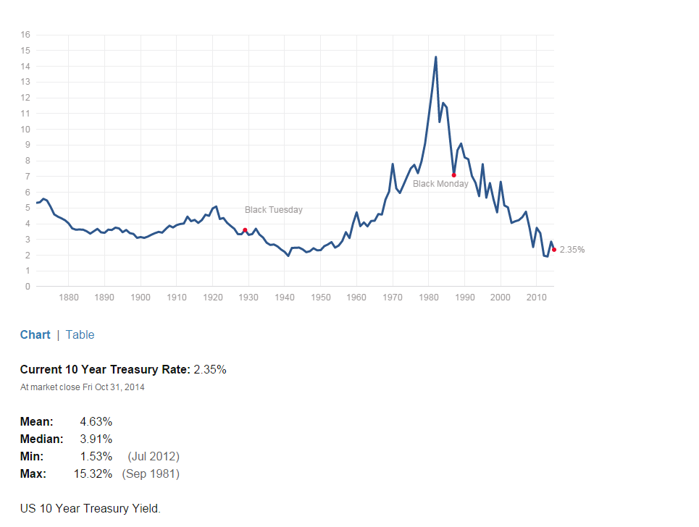

Small and Mid-Caps
For mid-caps and especially small caps, the valuation story is a bit more problematic as both trade at higher valuations (nearer to 20 for their aggregate P/E). And both have underperformed large caps this year. There is an article in Barron’s that discusses this more fully.
Barron’s - Size Matters

Interest Rates
Interest rates act on financial valuations the way gravity acts on matter: The higher the rate, the greater the downward pull. -- Warren Buffett
The key questions for investors are:
- Will interest rates stay low?
- If interest rates rise - what happens to the market? And what is good to own?
Associated with the above questions are two primary worries:
- If interest rates stay low – does that indicate a weak economic recovery and a low growth environment?
- If interest rates rise – it will be indicative of economic recovery and growth, which is good. But the worry is rising rates may mean inflation is on the horizon – And higher rates will slow growth, increase the cost of debt to corporations and make stocks less attractive, especially relative to bonds, which will be issued with higher coupon rates.
So the stock market always has worry. Worry is a good thing, it keeps the market in balance and can dampen excess. So what is the reality? To figure that out, we first need to look at the Fed.

The Fed

The Fed’s Mandate:
The Congress established the statutory objectives for monetary policy--maximum employment, stable prices, and moderate long-term interest rates--in the Federal Reserve Act.

The Fed’s Current Position:
In the FOMC's (Federal Open Market Committee) most recent Summary of Economic Projections, Committee participants' estimates of the longer-run normal rate of unemployment had a central tendency of 5.0 to 6.3 percent.
Despite stock market volatility and global economic troubles, the Federal Reserve on last week agreed to end bond purchases that have supported U.S. economic growth since the 2008 financial crisis, marking a milestone in the five-year-old recovery.
At the same time, the Fed pledged to keep its benchmark short-term interest rate near zero for a "considerable time" after the bond buying ends. The Fed did upgrade its view of the labor market but gave no clear signal that it planned to raise its benchmark rate earlier than the mid-2015 time frame previously indicated by Fed policymakers despite the solidly performing U.S. economy.
The full press release is here: FOMC press release October, 29 2014

Low Interest Rate Periods - Historical Performance
So how do stocks do in low/decreasing interest rate environments. We have to go back a ways.
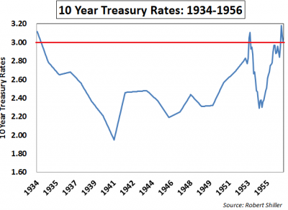
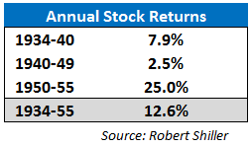
In the 1934-1940 period, rates decreased. In the subsequent periods (1940-1949 and 1950-1955), they increased ever so slightly. There was plenty of volatility and lots of ups and downs in the period. Specifically there were four recessions with an average contraction lasting eleven months, or a recession roughly once every five years. However taking the long term view, stocks performed quite well in a low interest environment.

Summary
Bond purchases have ended, but interest rates will be staying low for the foreseeable future as the Fed does not want to hinder the trend towards lower unemployment. If interest rates stay low, the expectation would be that the stock market would continue as it, generally trending upward in an uneven way. However assuming no further expansion of P/E multiples, price appreciation would expect to moderate more toward the rate of economic growth plus return accrued from dividends and earnings growth that exceeds economic growth via share repurchases. So mid to upper single digits of growth as a longer term expectation with the same sectors leading that has led the last three years (Healthcare, Discretionary, Tech, Industrials).

Rising Rates
But what happens when do rates rise….
To understand the impact of rising rates, let’s look at some history. Since interest rates have been falling since September of 1981, you have to go back 30+ years to find periods of rising interest rates. Basically the period from the mid 50’s to the early 80’s was characterized by a sustained long term upward trend of higher interest rates with a couple of small pullbacks in the 1960 and 1970 timeframes. So how did the markets do?
The following table shows the 10 year treasury yield changes in each decade along with the corresponding S&P 500 returns:

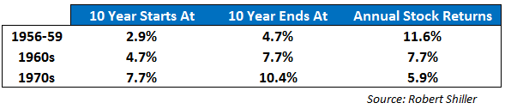
The table shows that stocks could handle the rise in interest rates quite well at the start, bit over time the effect of interest rates definitely hindered returns. Note by the 1970’s, inflation was running in the 7% range, so real returns were actually negative. It was an ugly decade. It seems that Warren Buffett’s gravity comment seems particularly appropriate.
However if rates do rise, you will have plenty of time to decide what to do. A study by Omega Advisors showed that on average the market does not decline significantly until 29 months after the first rate hike.
So if rates start to rise, while there is likely to be turbulence, markets should fare OK for quite a while. However if the interest rate rise is sustained and prolonged, then look out. Lower returns and higher inflation will likely make stock market investing a very unappealing choice.

What Sectors Work in a Rising Rate Environment
Rising rates generally mean a strengthening economy. Sectors that especially benefit are Financials, Discretionary and Industrials. Financials benefit from margin expansion (their spread is bigger) and fewer non-performing assets. Discretionary and Industrials benefit from increased consumer demand. Tech can also benefit as well. Note there is a deeper discussion of this on Investopedia.

Cycles

The Presidential Cycle
A study done at Pepperdine University in 2012 concluded that there is a propensity for the DJIA to rise during the second half of the four-year presidential cycle. The authors believe this pattern has been repetitive since 1950.
The cycle begins on October 1 of the second year of the presidential term through December 31 of the fourth year, the favorable period or (MFP). Historically, this period performed much better than the unfavorable period, from January 1 in the first year of the presidential term through September 30 of the second year.
The link for the full study follows:
The Four-Year U.S. Presidential Cycle and the Stock Market
So we also have the presidential cycle on our side, at least through December 31st of 2015

Sell In May and Go Away
The old saw “Sell in May and Go Away” is meant to capture the essence of a cycle where stocks perform much better in the period between Nov 1st and May 1st then they do between May 1st and November 1st. There is historical truth to this cycle. I looked at the SPY, which is an ETF proxy for the S&P 500 between the years 2000 and 2013 and found the following:
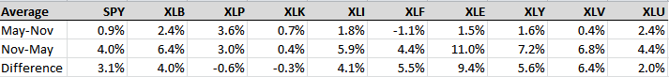

Note that for the S&P 500, the sell in May gain was 0.9% whereas the buy in Nov gain was 4.0%. Sector wise energy (XLE), health (XLV), discretionary (XLY) and financials (XLF) showed the biggest period differences. Staples (XLP) and technology (XLK) actually did better in the “Sell in May” periods.

Both Factors Together
The following blog entry describes the effects of the presidential effect and the sell in May effect together.

The Incredibly Bullish Seasonal Period SPX Is Entering

Let’s Find Some Stocks
It looks like the long term investing environment is pretty good. Let’s find some stocks based on what we have learned. First we will focus on Healthcare, Discretionary, Tech, Industrials for now and add in Financials if we think rates will rise. We will look for companies that are growing, getting more efficient and are not reliant on debt to finance growth. If rates rise, debt will become more expensive.
I have created a screener called “Long Term Growth” that embodies these factors and it is in the Stock Rover Library. Also the 50 top ranked stocks that passed the watchlist on Nov 5th are also in the library as a watchlist.

Long Term Growth Screener Filters
- Preferred sectors
  - Healthcare
  - Discretionary
  - Industrials
  - Tech
  - Financials
- Company Size – Mid Cap and Large Cap
  - Market cap > 2 Billion
  - 250 or more employees
  - At least 25,000 shares traded per day
- Long term debt to total capital not increasing in each of last two years
- Net Margin improving each of the last 2 years
- Improving ROIC each of the last 2 years
- A share count increase of no more than 2% in over the last 2 years

Long Term Growth Screener Quant Rankings
Valuation (35%) : EV/EBDITA (10%)
P/E (10%)
Forward P/E (5%)
PEG Trailing (5%)
PEG Forward (5%)

Growth: (35%): 1, 3 and 5 Yr. Sales Growth (10%)
1, 3 and 5 Yr. Operating Income Growth (10%)
1, 3 and 5 Yr. EPS growth (10%)
EPS Next Year Change (5%)

Efficiency (20%): Return on Assets vs. Industry (10%)
Return on Equity vs. Industry (10%)

Balance Sheet (10%): Long Term Debt to Total Capital (5%)
Net Cash as a % of Market Cap (5%) - Custom metric auto imported from library

Summary
We have spent a lot of time looking at Macro economic data to determine whether now a good time to invest in Stocks. And if it is, what makes sense to invest in given today’s environment.
In the course of our analysis, we answered the following questions.
- Is the economy sound? Yes
- Is the market expensive? Slightly
- Will interest rates stay low? Until at least mid-2015, probably longer
And if interest rates rise…
- What happens to the market? Returns will weaken, but it takes a while for that to happen
- And what is good to own?` Financials, Health, Discretionary, Industrials, Tech

